BLOCK PARTY – JANUARY 2022 – HOURGLASS
As we come to the end of one year and the beginning of another, our blue hour glass block is full, celebrating completed 2021 quilts and planned projects for 2022. This easy block is made up of 4 half-square triangles.
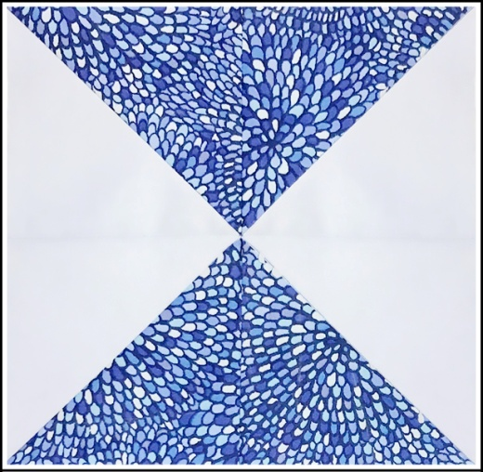
Cutting:
- Two blue fabrics, 1 light and 1 dark. Choose prints, solids, or tone-on-tone.
- You’ll need 4 squares, so cut two 4 7/8-inch squares from each fabric.
- Lightly starch the squares.

Sewing: All seams are .25-inch.
- Stack a light and dark square with right sides together. Draw a diagonal line from corner to corner on the light fabric. Sew a .25-inch seam on each side of the line. Repeat, using the remaining light and dark squares. Press each square to set the seam.
- Cut each square on the diagonal line, creating a total of 4 half-square triangles. Press seams to the dark sides.
- Arrange the squares as shown in the picture. Sew the horizontal and vertical seams, carefully matching the points.
- Press well. Block size: 8.5-inches

To participate in the January Block Party, make an Hourglass block as described; mail or drop off to Karel Peer. Your name will be entered once for each block received (enclose a note if you don’t want your name in the drawing). Blocks must be received by January 22. The winner will be drawn and announced at the January 24th SCVQA meeting with pictures of the blocks and the winner’s name in the February newsletter. Happy New Year from Sharon Frieson & Karel Peer

